Portlaoise Athletic Club
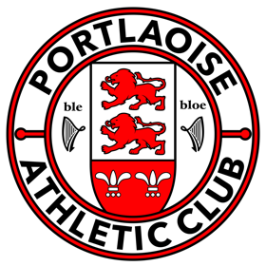

Athletics Ireland Inclusion Policy
It is our aim to continuously reflect on our experiences to ensure that we foster an inclusive environment for all children engaging in our activities. Through our contact we can create a child centred environment where children with additional needs are included, protected and provided equal opportunities to achieve their full potential with respect and without discrimination.
We believe that our Athletics Programmes can be a positive channel through which children can have fun, feel included and through participation have engaging and worthwhile experiences. Echoing the United Nations Convention on the Rights of the Child we should provide an environment “conducive to the child’s achieving the fullest possible social integration and individual development”.
Through partnerships with parents we encourage participation for children with disabilities removing, where possible, the barriers to inclusion. We can through such partnerships determine if additional available resources could be sought to meet the changing needs of all our members. We will create an awareness of inclusion amongst our coaches and clubs to support them in its provision.
We recognise that the needs of each child are different and we work to ensure that in all that we do we have the interests of each at its heart. Inclusion provides every child the opportunity to take part and we provide an environment where no one is turned away isolated or excluded. Responding to individual children’s needs ensure that we provide opportunities while setting individual goals.

